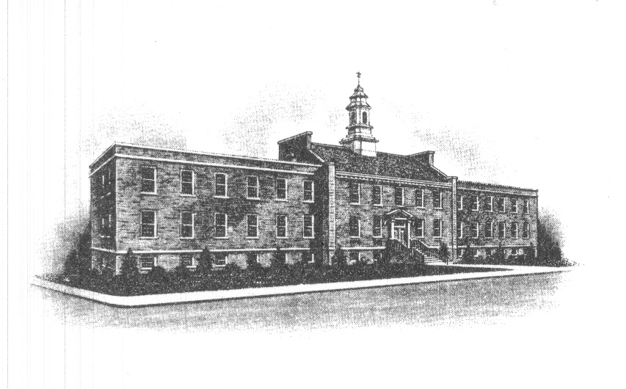
The Borough of Sayreville
Sayreville Board of Adjustment
167 Main Street
Sayreville, NJ 08872
(732) 390-7077 - Phone
(732) 390-7458 - Fax

ZONING BOARD MEETING CANCELLATION ANNOUNCEMENT

Take notice that the regularly scheduled meeting for November 21, 2023, of the Zoning Board of Adjustment in the Borough of Sayreville, N.J. has been cancelled.

The next meeting will take place on December 13, 2023 at 7:30 PM. The scheduled meeting will be held in the Council Chambers on the 3rd Floor in Borough Hall, 167 Main Street, Sayreville, NJ 08872.

Notice of the cancellation of the November 21, 2023 meeting will be posted on the Borough Website and on the bulletin board in Borough Hall, and noticed in The Home News Tribune. Any questions and/or concerns please feel free to contact
Joan M. Kemble, Board Secretary at 732-390-7077.

Joan M. Kemble
Secretary
Zoning Board of Adjustment

